
Light & Motion 2014 IT Revamp Proposal
Contact:
North America West Coast Headquarters
212 Thompson Sq., Mountain View, CA 94043
E-mail: info@lopoco.com Web: www.lopoco.com
Tel: 650.906.9448

New Virtual Machine Host
We propose to provide a pair of machines that will function as a Virtual Machine cluster, equally providing computing resources to whatever task needs them. The two machines clustered together will provide excellent long term growth capabilities and resiliency, as the VMs can be migrated from one machine to another. Additionally, if one of the servers fails, the VMs that were running on it can restart on the remaining machine with very little down time. If, at any time, it is determined that more machine resources are necessary, additional machines can be purchased and added to the cluster. Each VM server in the cluster will have 12 logical cores and 128GB of ECC memory.
Lopoco has architected two possible options for the VM storage. VM storage refers to the virtual disks, and all the data that would reside on them, that belong to each of the virtual machines running on the cluster. The two options for handling this important data differ in the way that storage is implemented. Option 1 utilizes an external network file server. Option 2 incorporates the storage into the VM servers themselves, and backs up that data to the other machine via replication. The costs associated with each option are detailed in the quote pages later in this document.

VM Cluster Option 1
All storage needs of the VMs will be located on a separate high performance network file server machine, providing very short failover delays for VMs with no data loss. The network file server machine will provide 6TB of high performance Raid-6 storage utilizing hybrid disk drives. Raid-6 means that even if two disks fail at the same time, which would be extremely unlikely, your data would still be safe and useable. The file server will also provide the network file serving needs of other
L & M applications or clients, as needed. The network file serving resource can be utilized to great advantage by users and IT planners. This option also makes future expansion of the VM Cluster a significantly easier operation.

VM Cluster Option 2
All storage needs of the VMs will be replicated between the two machines, providing very short failover delays with minimal or no data loss. This option has each server in the VM cluster configured with 4TB of replicated Raid-6 storage utilizing hybrid disk drives for good performance. There is some thought that the replication technology itself will prove to be somewhat fragile and require a more-than-desireable amount of support and management. It does turn out to be slightly cheaper than option 1, and doesn't leave a single point of failure like option 1, hence we are proposing it as an alternative to option 1.

Engineering bugtracking and wiki server (landm)
Due to this virtual machine setup, we recommend that the landm server become a VM on the VM cluster. Moving that over is a simple process that Lopoco can take care of at no extra charge.

Dell PowerEdge 2900
Let RayneTech haul it away. The money they make recycling it should compensate them for the trouble. It is old, and extremely power hungy and wasteful, not to mention lacking performance compared to any modern computing technology. The two new VM servers together will use considerably less power than the PowerEdge 2900 all by itself. In fact, just the disk drives of the RayneTech proposed VM server will use more power than one of the Lopoco VM servers, nevermind the new disk drives they are proposing to buy for the PowerEdge 2900.

OS Licensing
We propose using Proxmox (Linux) as the VM host operating system. Professional support for ProxMox can purchased for $560/yr/machine for 10 support tickets, free upgrades, customer portal, etc, however we believe the best solution is to supply the support to Light & Motion ourselves at the same rate. That will provide L & M with a greater level of support because we will obtain and apply all updates, patches bug fixes in addition to handling the configuration and monitoring.
This will obviate the need for the $6k Microsoft Windows Datacenter License, and maybe also the 50 CAL (client access licenses), since you already have those with the SBS you have. According to Rayne, you can continue to use that without upgrading it, probably for another year. At that time, you can upgrade it, and the cost will likely be around $2k. I don't know if additional CAL licenses will be required. We can take a look at the clients you have, determine which ones could be thin clients running non-Windows operating systems, and determine a plan to put those in place.

Upgrade Firewall/Router and switch
Rayne wants to upgrade the SonicWall firewall appliance. The proposed Cisco 5512X is a very pricey, ultra-premium product that is drastic overkill for your application. I propose you stick with the appliance you have for another 6 months at least.
The 48-port Cisco switch sounds good to me. It's a good solid product, and the best you'd probably be able to do is find a product from HP for a hundred dollars cheaper, or a used one for half price. It's not that expensive to begin with, so I'd go with that.

Offsite DR Backup Services
Lopoco at this time would like to propose it's own cloud offsite backup service. This will be utilized for both offsite backup of xTuple database and backup of VM images. The cost is $260/mo. This represents $1,000 per year savings right off the bat, and includes the DR backup of the xTuple database, which the Datto service does not.

Managed Services and Support Heirarchy
Lopoco is proposing a small collection of managed services to go along with Light & Motion's IT needs. These will include various kinds of support as well as maintenance and monitoring.
VM Cluster Host environment support $560.00/yr
Software updates
Configuration
Issue resolution
Offsite DR Backup $3,120.00/yr
Disaster recovery backup of xTuple database
5 days/week; 4 weeks/mo; 12 months/yr
Disaster recovery backup of VM cluster
All templates; 3 daily snapshots; 1 weekly snapshot
Disaster recovery backup of backup server
5 days/week; 4 weeks/mo; 12 months/yr

These backup and support services will be provided in conjunction with support and services provided by RTS. In order for you to have an effective support experience, it is necessary to outline the support heirarchy so that L & M employees know how to obtain support in an orderly and effective manner.

Support | Responsible provider
Windows Support, Desktop & Server | RTS
Email server | RTS
VM cluster software | Lopoco
xTuple application | (1) xTuple support, (2) Steve B., (3) Lopoco
Desktop user | RTS
Hardware support of Lopoco sourced servers | Lopoco
Timemachine backups | Lopoco
DR backup and restore strategy and plan | Lopoco

Backup Server
On-site backups is an essential part of any IT plan. Currently, RTS backs up the Windows SBS server, but nothing else is backed up. The xTuple machines are a replicating pair providing good service availability, but the data is not currently backed up anywhere.
We are proposing an on site backup server where backups can easily be stored and accessed for restoration or recovery options. The VMs that run on the VM cluster will be backed up nightly, with full restorations or even temporary instantiations possible in just minutes. In addition, daily backups of the xTuple database will be stored on the backup server for added extra safety. And lastly but still importantly, client computers (laptops and desktops) will be backed up on the backup server, with backups of user files accessible directly by the user without administrator interaction.
Mac clients can be backed up using Timemachine, which allows users to access their own backups as well as a method for administrators to rebuild an entire hard drive. Windows and other clients can be backed up using equivalent software for those operating systems, with the Backup server operating as network storage. RTS can set that up on Windows clients as necessary.
Currently, backups for Mac clients is being done on the landm server, however I believe they have all lapsed, and nothing is being backed up at the present time. There are 10 Mac desktops and 4 laptops. We propose our low power LP-8240 microserver as a dedicated Backup server, configured initially with 8 Terabytes of Raid-6 backup storage. This means that even if two of the drives at the same time, your data is still safe. This will handle existing machines, both virtual and real, and allow for a modest increase in the future in the number of clients. The amount of storage can be expanded in the future.
This server will function as a generic network file server for Windows, Mac and Linux clients in order to facilitate their backup applications.

Uniterruptible Power Supply
Due to the problems encountered when power was lost last time, we propose that a more stable and professional UPS strategy be implemented. This would entail the removal of the old, mostly failing UPS boxes, and replacing them with a pair of APC SmartUPS X2000 rackmount units that can be installed in series, so when one is out of juice, the next one takes over. Moreover, the batteries are replaceable and recycleable, which is much more eco-friendly than meerly tossing them when the battery has expired. These units are about $1200 a piece, and will protect your IT equipment and data in the manner you really need. Furthermore, they can be configured to send you a message when the batteries need replacing, so that you don't encounter a situation where you need your UPS to save your data and equipment, but the batteries are dead, which is what happened last time because RTS wasn't on top of the situation when they really should have been.
These UPS units install in the IT rack along with the rest of the IT equipment, rather than sitting on the floor under foot. They provide a predictive analysis of the day and date when the batteries will need replacing, which can be put in a calendar or reminder. Batteries are guaranteed for 2 years but expected to last 3 years. These UPSes are not listed in the quote, but can be added upon request.

Cost Reductions
We estimate the following cost reductions versus the status quo and RTS latest proposal.
Option 1
Product | RTS | Lopoco | Savings
Servers/networking hardware/software | $23,276.00 | $23,446.00 | -$170.00
DR offsite backup; per year | $13,140.00 | $3,120.00 | $10,020.00
Replication management; per year | $2,400.00 | $560.00 | $1,840.00
Total this year | $11,690.00
Option 2
Product | RTS | Lopoco | Savings
Servers/networking hardware/software | $23,276.00 | $20,609.00 | $2,667.00
DR offsite backup; per year | $13,140.00 | $3,120.00 | $10,020.00
Replication management; per year | $2,400.00 | $560.00 | $1,840.00
Total this year | $14,527.00

Further cost savings not currently known: RTS is proposing a single price model for many IT management activities. One activity which you won't need is “Cloud data backup for workstations and servers.” However, they list that as $750/mo *Optional. That could mean that it's part of the $1,651 monthly already, so that being eliminated would result in a $901 monthly from them in that case. But doubtful it is already included in that $1,651/mo, so I have included it in the table above.
Their managed services list doesn't include on-site backups, which Aaron said in the meeting that they are doing. Are those billed as an additional cost to the $1,651/mo (they couldn't make it $1,650?)? We would consider the on-site backup server proposed in this document to be a replacement for such services, so any additional cost savings for that service would also need to be considered.

Roadmap
The plan is to get rid of as much proprietary licensed (costly) software as possible. In other words, get rid of Windows were possible with its high cost-to-value ratio.
This proposal is a good first step in that direction.
The next step would be to replace the costly Windows Remote Desktop Service. Not only is this a costly recurring license – there's plenty of free open source software that can do the same things – but it also has to run on a separate Windows server from the so-called “Domain Master” Windows server that runs Active Directory (otherwise known as LDAP) and provides directory and authentication for all the Windows machines on the network. We can do a study of what ways WRDS is used by your remote employees, and use that information to craft a plan to transition all the users to open source equivalents.
Step 3 would be to identify all the machines in the building that don't absolutely have to be Windows machines, and re-install them with Linux or ChromeOS. Figuring out what applications are used from those client computers is the key to creating a strategy for switching them over. Many machines are used just run a web browser as well as email processing and possibly light document or spreadsheet use, and therefore don't require Windows or Microsoft Office.
Step 4 would be to replace Microsoft Exchange with an open source email server. We ran into some snags with this last time, some related to switching only one user, some related to RTS switching that user back to Exchange instead of fixing the real issue, and some related to lack of a more structured beta trial in conjunction with a timeline to switch all the other users over as well.


Quote
Option 1
Item # | Description | Qty | Price | Total
1 | Lopoco LP-6240-6H 128GB 1U Server | 2 | $4,986.00 | $9,972.00
 | Power usage Idle: 34 watts/TDP: 100 watts
 | 2 x 64GB SSD for OS Host environment
 | Hardware installation at customer site
2 | 2-year additional warranty | 2 | $320.00 | $640.00
3 | Software installation & configuration | 1 | $2,500.00 | $2,500.00
4 | Lopoco LP-2230-10H 32GB 1U File Server | 1 | $3,655.80 | $3,655.80
 | Power usage Idle: 35 watts/TDP: 70 watts
 | 6TB High Perf. Raid-6 Storage (8 x 1TB SSHD)
 | Hardware installation at customer site
2 | 2-year additional warranty | 1 | $340.00 | $340.00
3 | Software installation & configuration | 1 | $500.00 | $500.00
4 | Backup and TimeMachine Server LP-8240-6H 16GB | 1 | $3,475.00 | $3,475.00
 | Power usage Idle: 22 watts/TDP: 38 watts
 | 10TB of Raid-5 backup storage (6 x 2TB HDD)
 | Hardware installation at customer site
5 | 2-year additional warranty | 1 | $320.00 | $320.00
6 | Software installation & configuration | 1 | $750.00 | $750.00
Subtotal | $22,152.80
Tax | $1,453.74
Total | $23,606.54

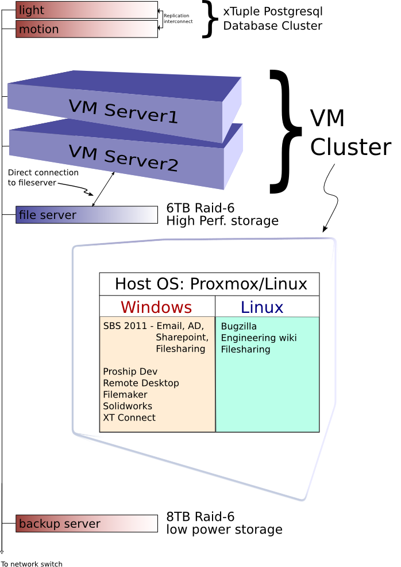
Systems & Applications Diagram
Option 1
Quote
Option 2
Item # | Description | Qty | Price | Total
1 | Lopoco LP-6240-8H 128GB 1U Server | 2 | $6,300.00 | $12,600.00
 | Power usage Idle: 40 watts/TDP: 110 watts
 | 2 x 64GB SSD for OS
 | 4TB Replicated Raid-6 Storage (6 x 1TB SSHD)
 | Hardware installation at customer site
2 | 2-year additional warranty | 2 | $340.00 | $680.00
3 | Software installation & configuration | 1 | $2,500.00 | $2,500.00
4 | Backup and TimeMachine Server LP-8240-8H 16GB | 1 | $3,799.00 | $3,799.00
 | Power usage Idle: 22 watts/TDP: 38 watts
 | 8TB of Raid-5 backup storage (6 x 2TB HDD)
 | Hardware installation at customer site
5 | 2-year additional warranty | 1 | $280.00 | $280.00
6 | Software installation & configuration | 1 | $750.00 | $750.00
Subtotal | $20,609.00
Tax | $1,393.92
Total | $22,002.92

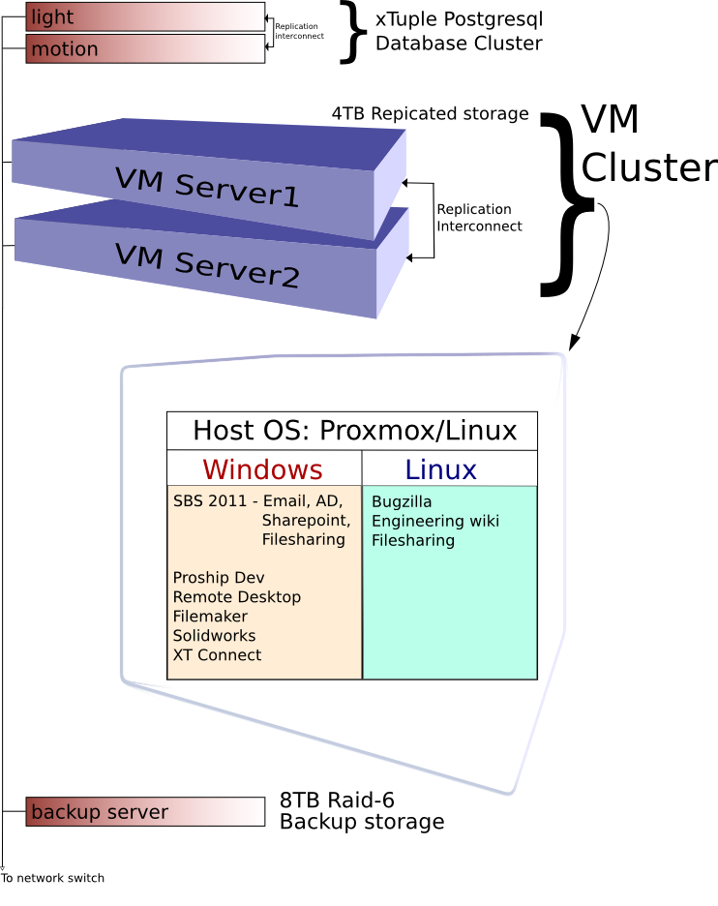
Systems & Applications Diagram
Option 2

