about lopoco

lopoco designs and manufactures ultra-efficient servers that use 50-75% less power than conventional servers without compromising on requisite performance or business continuity.
Our servers are built on proven, shipping technology without costly custom silicon. Our technology is disruptive to the industry, but not to the customer. All our current products use Intel or AMD 64-bit X86 CPUs¹.
team insights

Led by founder Andrew Sharp, a Silicon Valley veteran who joined Convergent Technologies in 1985, and has worked for Sun, SGI, HP and LSI, along with several startups.
Peter Theunis, CTO and co-founder, has more than 10 years of experience in large scale systems architecture at Yahoo! and multiple startups.
Jack Mills, VP Engineering, while at Intel was an architect of the Pentium and the Itanium processors; later Director of advanced processor research; also an alumnus of Convergent Technologies [advisor]
Mark Brine, CFO, is a veteran of Silicon Valley startups, starting at VLSI, later VP of Finance at semiconductor startup Discera; now Director of Finance at Cloudera [advisor/board].
Karl Pfister-Kraxner is developing & driving the commercials for our EMEA entity.
validation, IP & traction

- 3 patents pending; 10+ additional patents in preparation
- Revenue to date: >$110k
- 12 Customers
- 75+ Systems shipped
- 75% repeat customer rate
- Named “Most Efficient Certified to Date” by Power Assure's PAR⁴ energy efficiency rating system,
which has been adopted by UL and United Nations
- Data Guard Solutions Inc. (US/KSA), signed as distributor in GCC region
- Europe:
- Traction by Mobile Telecom Operators/global
- Market Research companies
the problem

Conventional servers waste more than half the power they consume. This is a lot of waste in today's world. These servers produce a large amount of heat, noise and vibration, all of which contribute to high failure rates.
the solution
Our milestone product line of ultra-efficient servers and storage appliances that reduces energy consumption, noise and vibration well over 50%, with many additional advantages to the data center operator because of these remarkable reductions.
For large data centers, the savings can be in the hundreds of millions of dollars. For smaller operations, the savings is dependent on the level of adoption.
market

The Total Addressable Market is $40-$50bb globally. Projected to be $60bb in 5-8 years, fueled by acceleration of cloud adoption and mobile application space. According to IDC, they see signs of a server refresh cycle, which we expect will continue to lift the market into 2015 and onwards.
lopoco target market focus on SME and IaaS/SaaS Providers
lopoco market vision in 5 years: TAM: $50bb; SOM: $8bb.
required funding

Seeking seed level investment round of $500k convertible note with the following milestones:
Take the company through the next 6-9 months with the following goals over that time:
- fund commercial entry into European Markets
- get the company in a position to seek Series A funding in 6-9 months
- fund targeted sales and PR programs with the goal of adding new customers
- ramp up manufacturing/fulfillment, engineering and support programs to match sales programs
- customer support infrastructure for +100 customers (most of this will be driven by product orders and funded by the resulting revenue, but some small amounts of funding will be needed ahead of orders.
team contacts

ceo: Andrew Sharp andy@lopoco.com
soft: Peter Theunis peter@lopoco.com
hard: Jack Mills jack@lopoco.com
finance: Mark Brine mark@lopoco.com
emea: Karl Pfister-Kraxner karl@lopoco.com
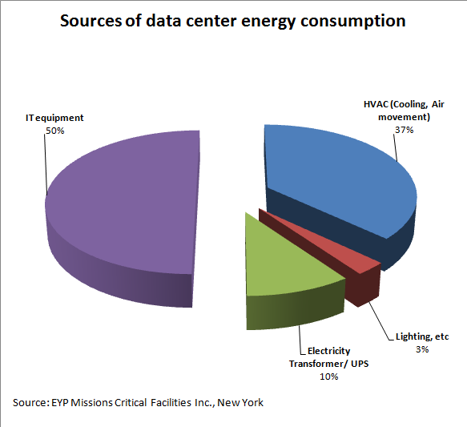
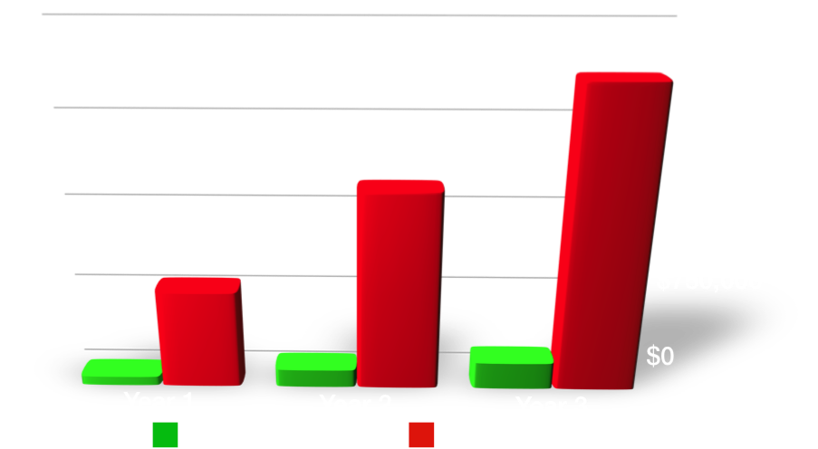
value proposition

lopoco green tech servers help data centers shred their monthly operating costs by 50% or more, all while preserving business continuity and compliance with conventional form factors, CPUs, and server options already familiar to customers.

The chart above shows that, except for lighting costs, a customer can save operating costs in all areas of data center operations by deploying lopoco servers.
go to market in Europe

Priority European countries: UK; Italy; and Germany, as they have the highest electricity costs. Highest value add based on tested and proven energy savings as Power Assure certified.
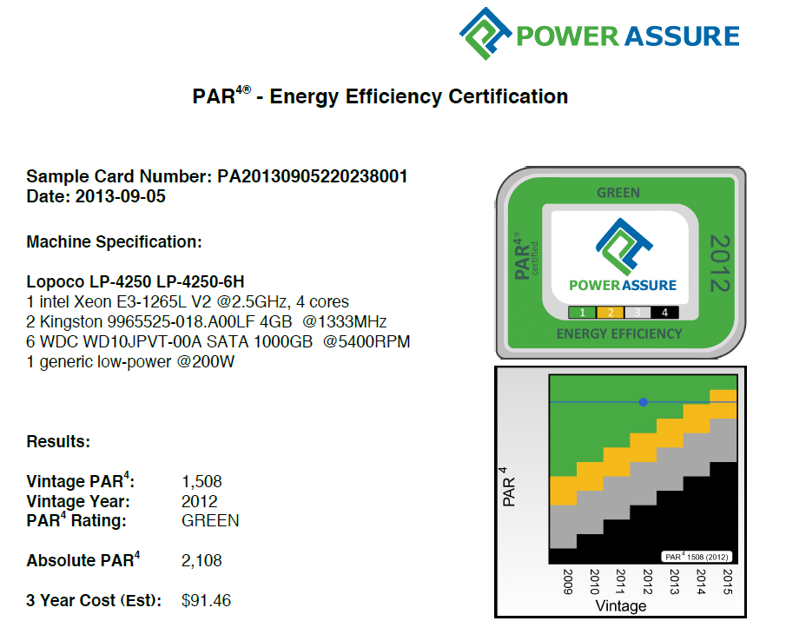
potential savings

The bar chart below illustrates the savings customers (20₵/KWh) can realize when utilizing lopoco servers.

TCO per 1000 servers for 3 years.
competition

Our main competition is the top tier server vendors, and while they do not make a direct competitive product, they are plenty of competition. Multiple self-styled efficient server startups (Calexda/Tilera, HP Moonshot, Seamicro, Servergy) are all making products with similar problems: costly; high power; proprietary silicon and packaging; weird processors; dubious efficiency. Put simply, they are making servers nobody wants. With high adoption risk and providing no business continuity, these products are seeing very little traction in the market, and have a very small SAM compared to lopoco.
[Note: Calexda closed doors 1/2014]
[Note: Seamicro acquired by AMD $335M 2014]
economy of scale
Currently manufacturing in California by two contract manufacturers with capabilities to expand to sites overseas. Components used are industry standard.
exit

Our disruptive product, combined with the acquisition aggressive server/storage industry indicates the most likely exit will be through acquisition. $400mm revenue in 3 years → $4bb acquisition valuation.
Similars:
- Aruba acquired by HP Jan. 2015 $3B
- SeaMicro acquired by AMD Mar. 2013 $335M
- Wyse acquired by Dell 2012 <$1B
- Cobalt Networks acquired by Sun 2000 $2B

