ME Firmware Update Guide for HuronRiver & ChiefRiver
Document Revision 0.3
Jun 29, 2012

This document has installation instructions to update your computer with the latest ME firmware version.
- During the boot, enter the BIOS setup by pressing Delete key.

- Browse through the BIOS menu, go to Exit page.

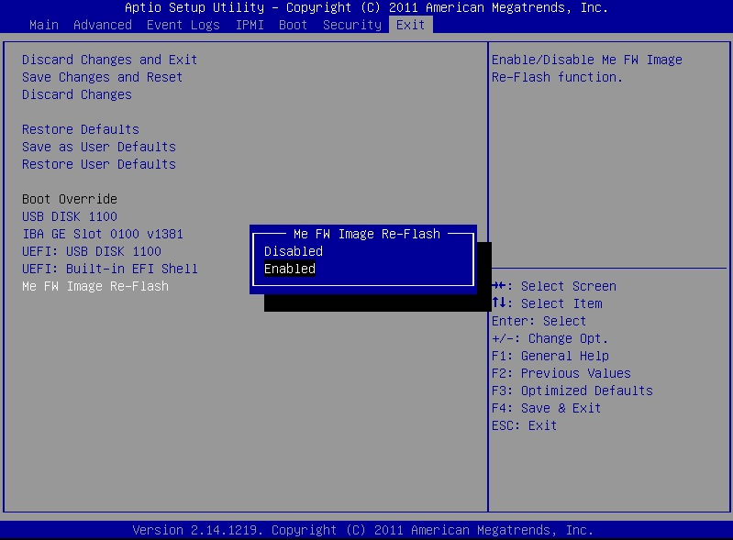

- Select “ME FW Image Re-Flash” and enable it.

- Select “Save Changes and Reset” to restart the system and boot to your USB flash drive.

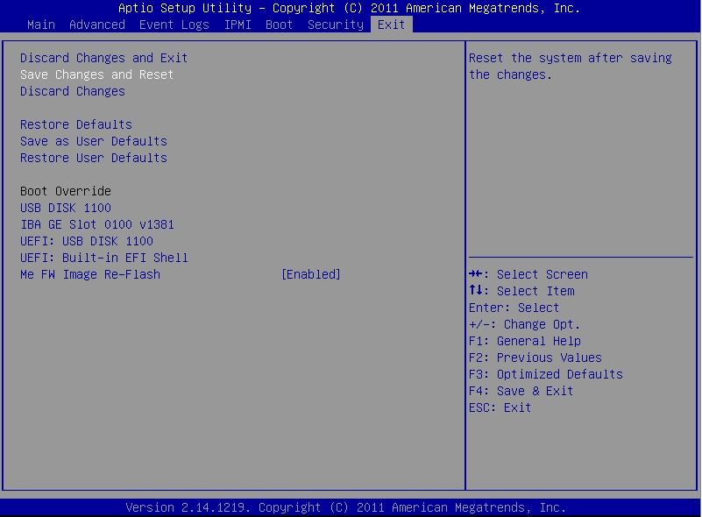

- The system will boot from the bootable USB Flash Drive that contains the BIOS flash package.

- To start flashing BIOS in DOS mode, enter:

afudos x9spvf.bin /p /b /n /k /r /me

Note: The exact .BIN file can be found in the BIOS flash package.

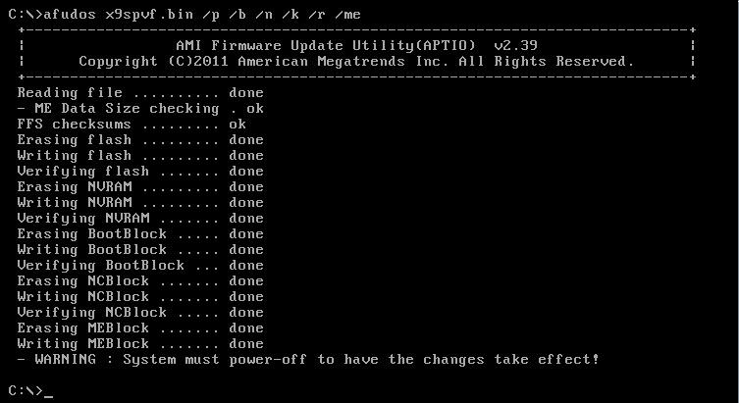

7. After the update finishes, power off the system and restart the system.

