Figures 1 and 2

Andy, please advice on these two figures. Does in fact a high efficiency server exhibit TDP2

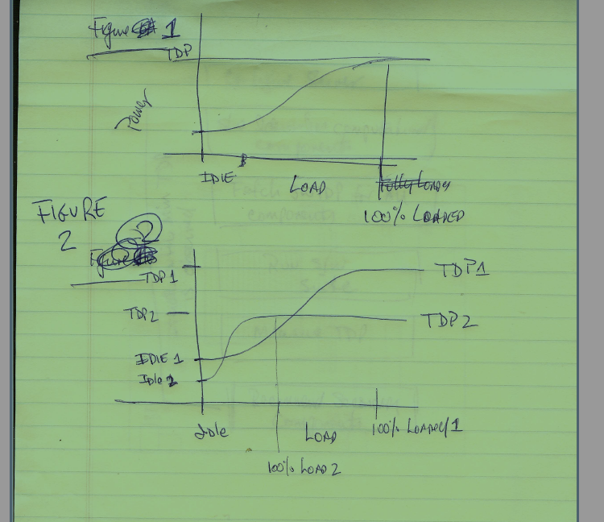

Figure 3

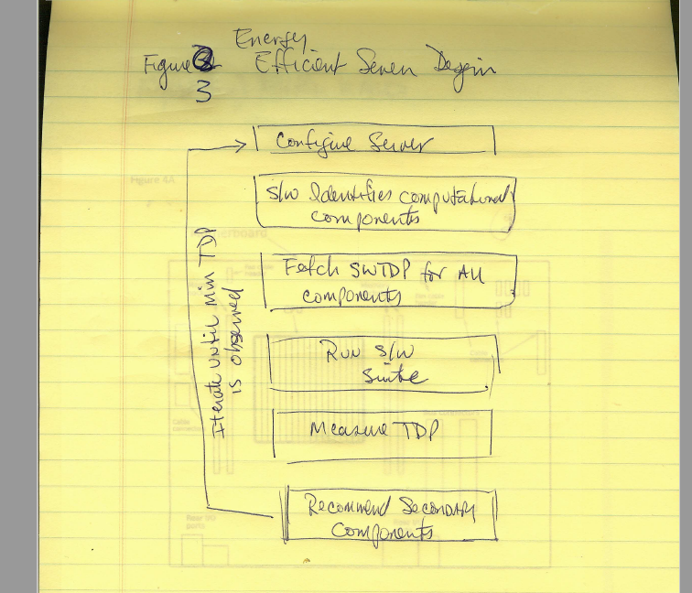

Figure 4A

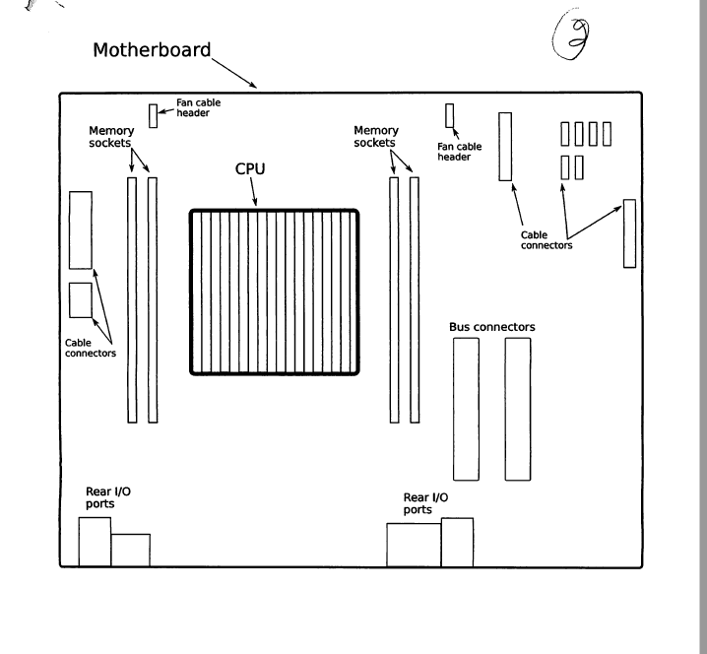

Figure 4B Mother Board Side View Airflow

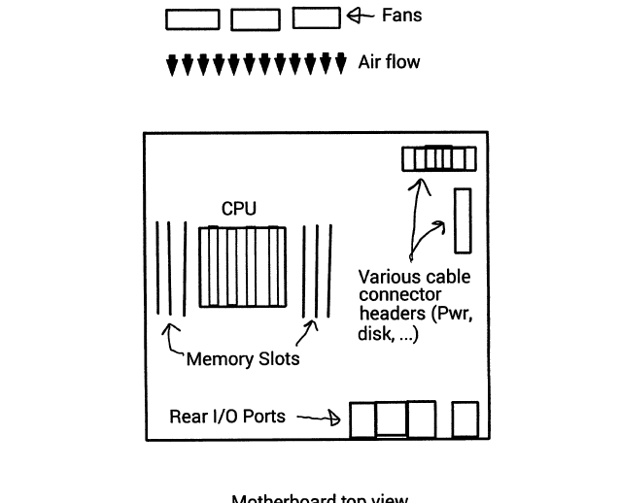

FIG 5

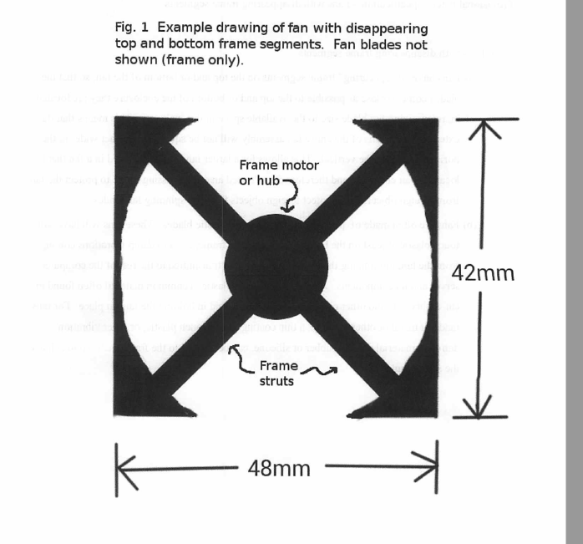

FIG 6

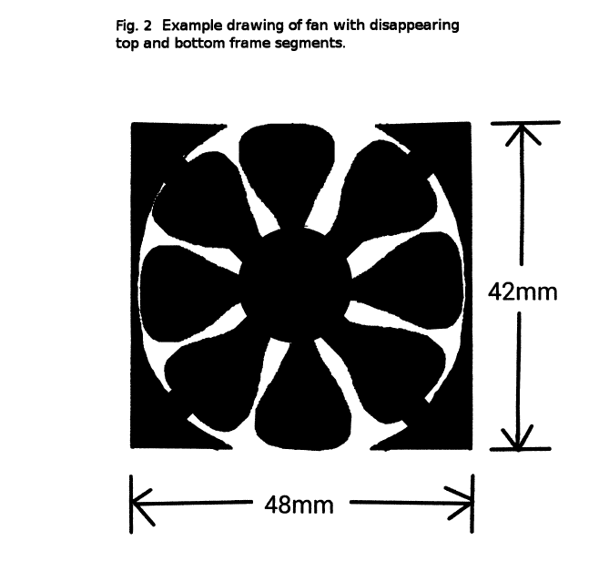

FIG 7

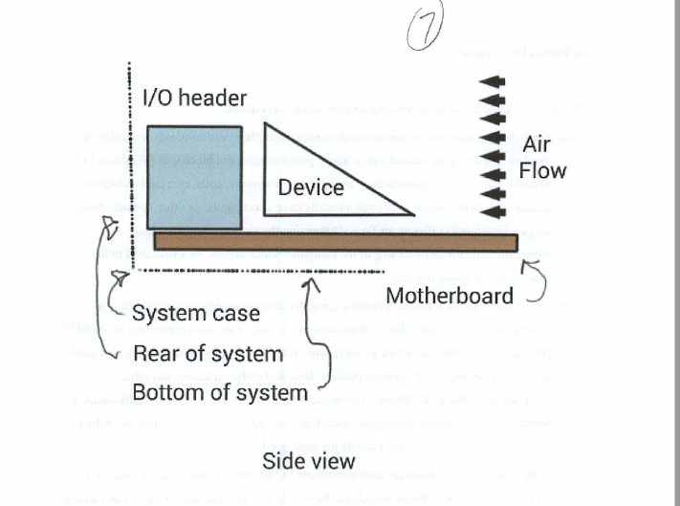

Figure 8

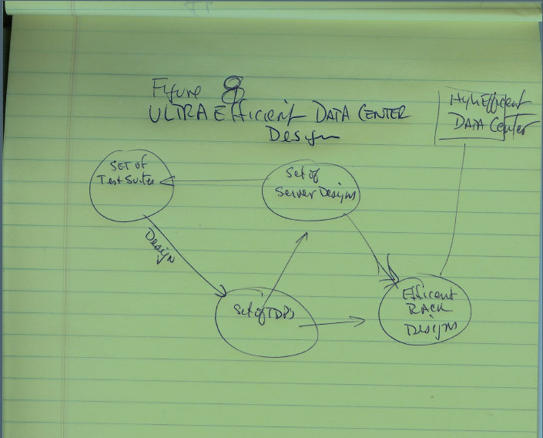

Andy screen capture below which we think is the design methodology of future data center from 8/9-8/11 workshop. Please confirm / advise so drawings can be created.

