Figure 1

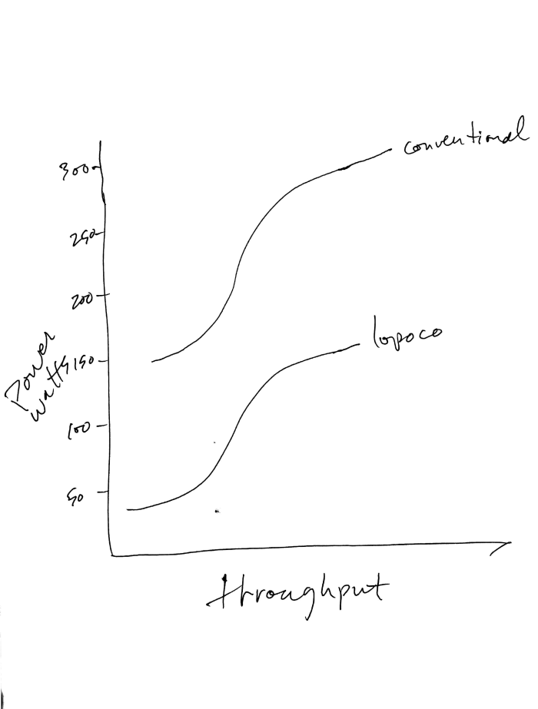

Notice how the curves don't align vertically. That's because we're willing to give up a small percentage of unneeded performance for large increases in efficiency. I tried to draw the curves to indicate less than 10% performance difference. For many applications that are not CPU bound, the actual throughput difference will be neglibilble.

Figure 3

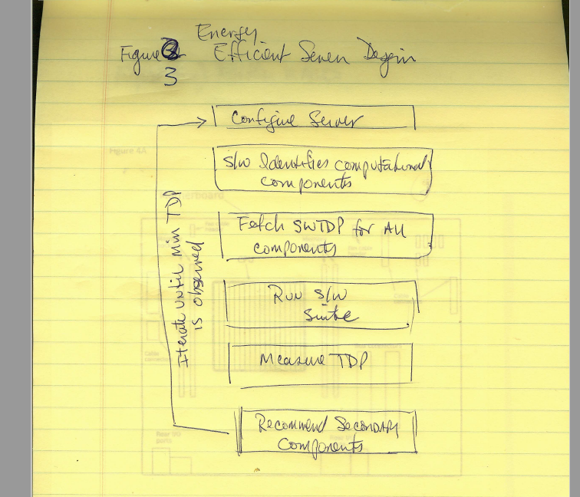

Figure 4A

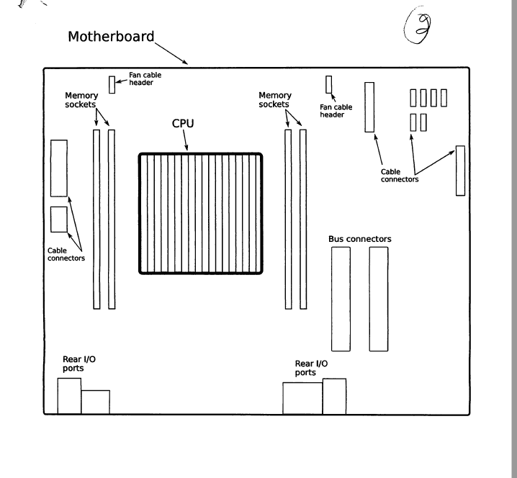

Figure 4B Mother Board Side View Airflow

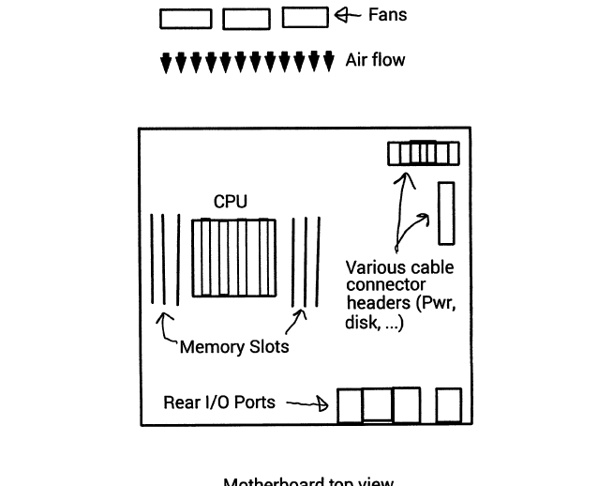

FIG 5

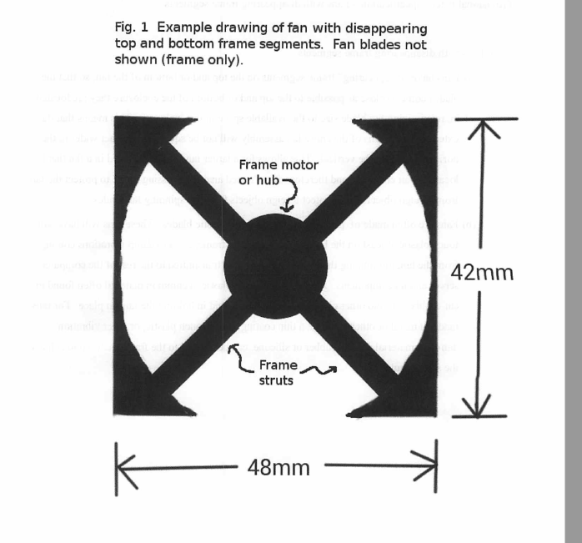

FIG 6

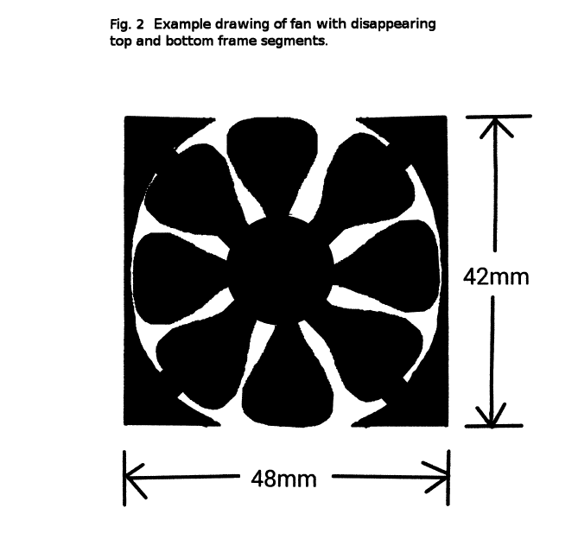

FIG 7

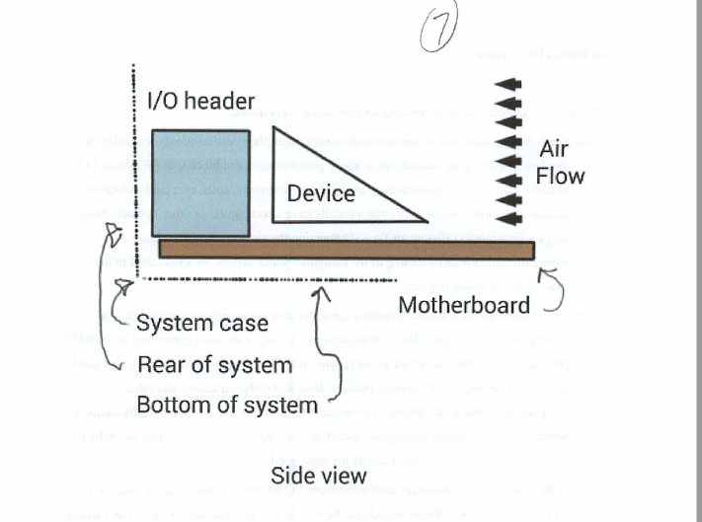

Figure 8

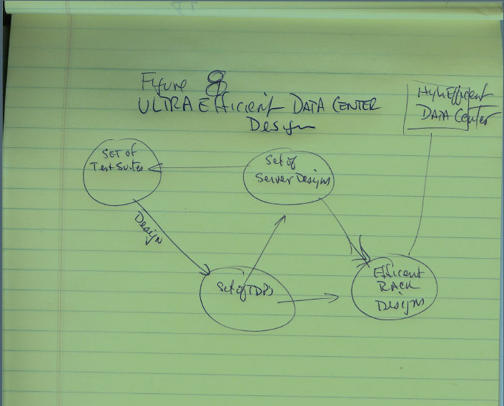

Andy screen capture below which we think is the design methodology of future data center from 8/9-8/11 workshop. Please confirm / advise so drawings can be created.

