Figure 1

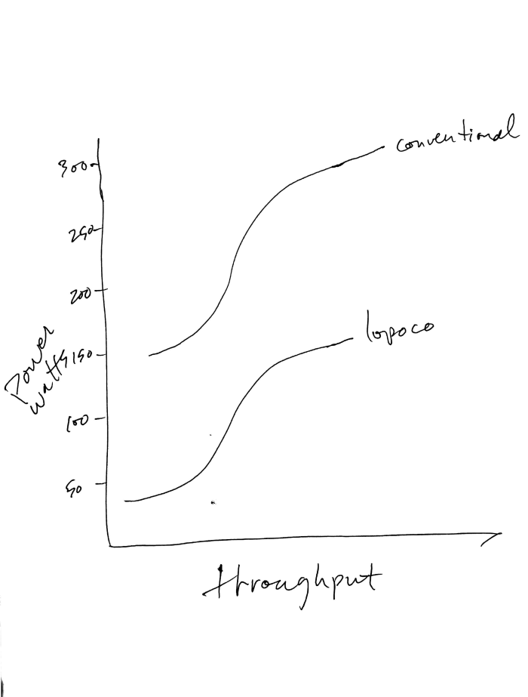

Notice how the curves don't align vertically. That's because we're willing to give up a small percentage of unneeded performance for large increases in efficiency. I tried to draw the curves to indicate less than 10% performance difference. For many applications that are not CPU bound, the actual throughput difference will be neglibilble.

Figure 2

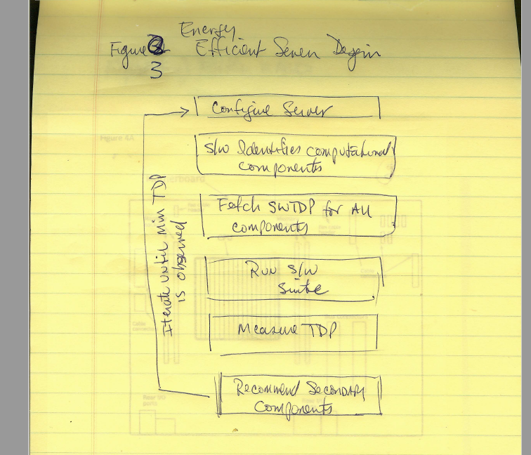

Figure 4

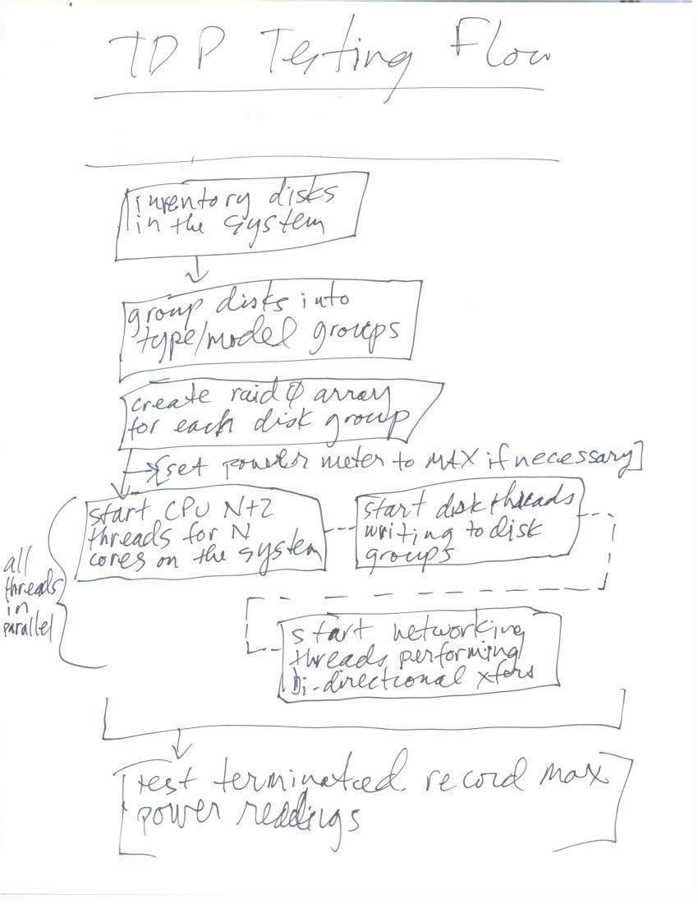

Figure 5A

[External PDF Document drawing-efficient-server-motherboard.pdf]

Figure 5B Mother Board Side View Airflow

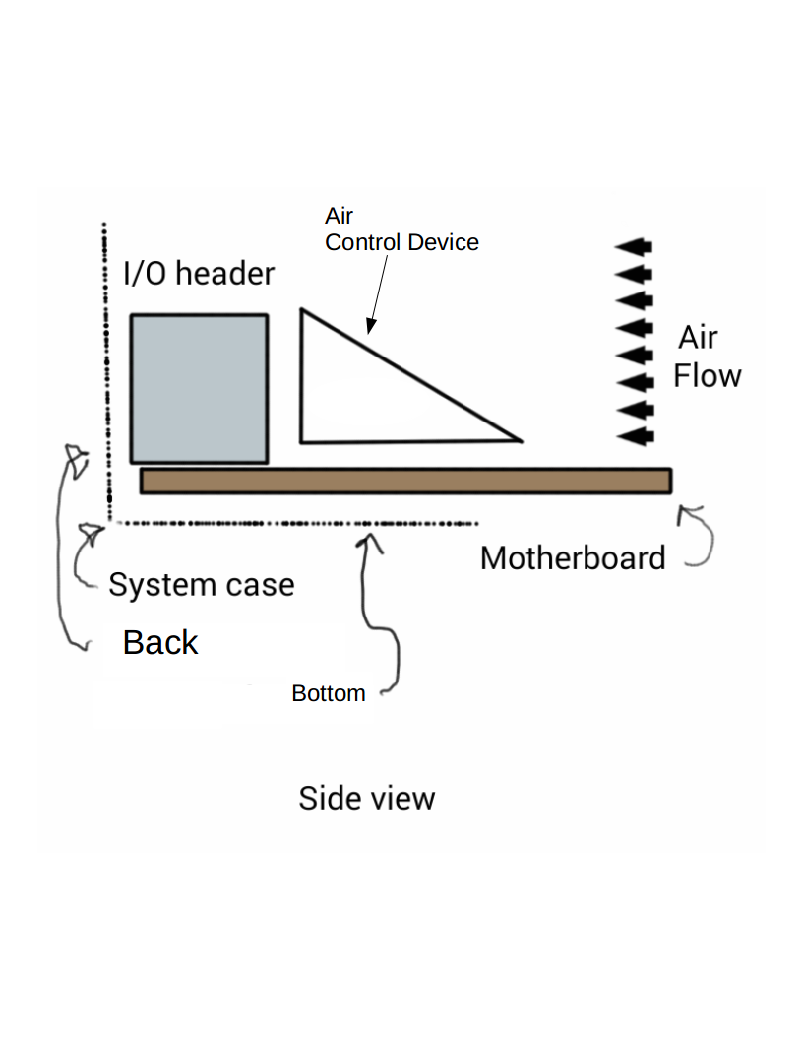

FIG 6

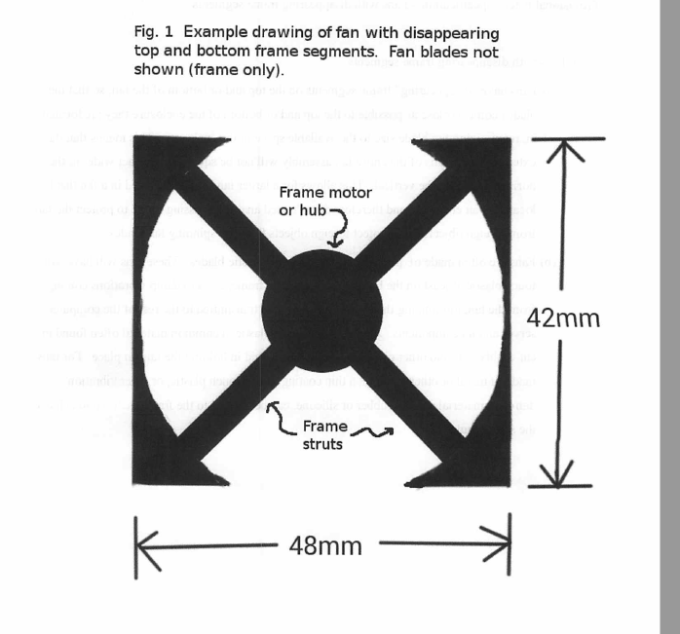

FIG 7

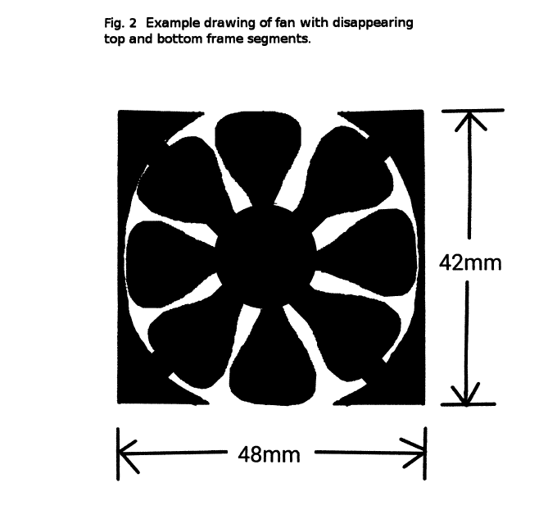

FIG 8

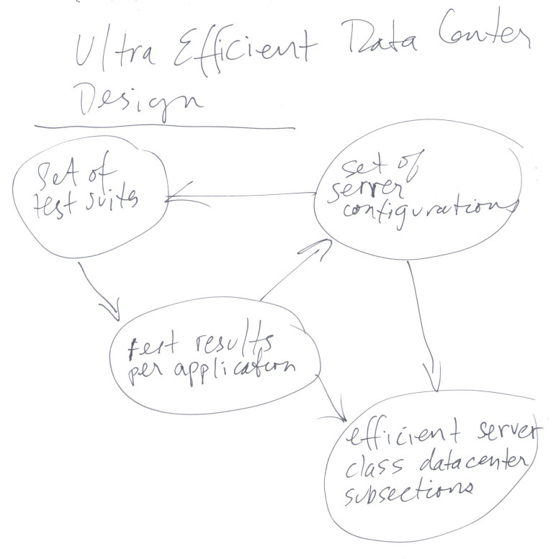

Figure 9.

