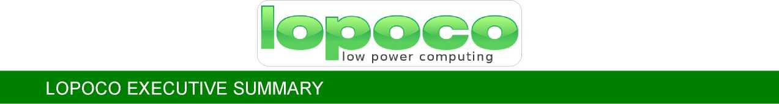

**Executive Summary**

Lopoco is bringing ultra-efficient servers to power hungry data centers that use 75% less energy and 50% less space than conventional servers, without compromising on performance or business continuity.

Our servers are built on proven, shipping technology without costly custom silicon. Our technology is disruptive to the industry, but not to the customer. All our current products use Intel or AMD 64-bit X86 CPUs

**Team**

Led by Cofounder Andrew Sharp, a Silicon Valley veteran who worked at Convergent Technologies, Sun, SGI, HP and LSI, and several startups. [andy@lopoco.com](mailto:%20andy@lopoco.com)

Peter Theunis, CTO and Co-founder, has more than 10 years of experience in large scale systems architecture at Yahoo! and multiple startups.

Jack Mills, Engineering Advisor, architect of the Pentium and Itanium processors at Intel; also an alumnus of Convergent Technologies.

Mark Brine, Financial Advisor, is a veteran of Silicon Valley startups, starting at VLSI, later VP of Finance at semiconductor startup Discera; now Director of Finance at Cloudera.

Karl Pfister-Kraxner is developing & driving the commercials for our EMEA strategy.

**IP & Market Traction**

* Patents pending
* 100+ Systems shipped
* 75% repeat customer rate
* Data Guard Solutions Inc. (US/KSA), signed as distributor
* Europe - Traction with Mobile Telecom Operators

**Manufacturing**

Currently manufacturing in California - two contract manufacturers trained in manufacturing our servers according to Lopoco proprietary designs. These CMs have the capability to expand manufacturing to sites in US and Europe/Asia.

**Business Model**

Lopoco understands the complexity of, and resources required to brand a new server offering in the highly competitive Server Market. As such, Lopoco is seeking a strategic-alliance server partner to continue its mission of energy consumption reductions in future designs of motherboards, cases, and I/O devices. Options exist for licensing or Lopoco acquisition. Andy Sharp and core team are available to engage (join/contract) with an acquiring company for technology transfer and future designs.

Value Proposition

Conventional servers waste more than half the power they consume. While operating, they produce large amounts of heat, noise and vibration, all of which contribute to high failure rates.

Lopoco's milestone product line of ultra-efficient servers use less than half the power of conventional servers, resulting in OpEx reductions of 50% or more. Such cost reductions go straight to a company’s bottom line, boosting profit margins and competitiveness.

By reducing power consumption of the IT hardware, a data center can downsize PDU/UPSs, HVAC provisioning and repair costs, and backup generator costs. Also, because Lopoco servers produce far less heat and vibration, they experience far fewer failures, thereby reducing IT maintenance costs.

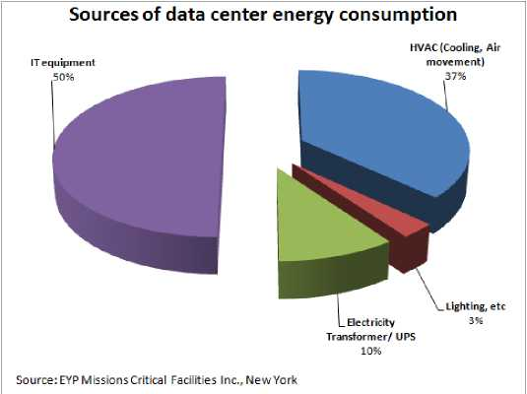

The chart above shows that, except for lighting costs, a data center operator can save OpEx in all areas of operations by deploying Lopoco servers. For large data centers, the savings can be in the $100s of millions.

The bar chart below illustrates the savings customers (20$/KWh) can realize when utilizing Lopoco servers.

**Market**

Lopoco is bringing a much needed product to the industry, which is hungry for energy efficient products that don’t disrupt their business. TAM is $51B globally, and that does not include storage products. Projected to be $60B in 5-8 years (IDC noted that 2014Q4 was the third consecutive quarter for server revenue growth, up 2.3%), fueled by acceleration of cloud adoption and mobile application space. According to IDC, they see signs of a server refresh cycle, which we expect will continue to lift the market into 2015 and onwards. SAM is about 80% of TAM, and SOM is roughly 20% of SAM.

Initial Target market: focus on SME and IaaS/Saas providers

Market vision: in 5 years: TAM $60B; SOM: $8B.

**Europe**

Priority European countries: UK; Italy; and Germany, as they have the highest electricity costs. Highest value- add, based on tested and proven energy savings as Power Assure certified.

**Lopoco Validation**

Lopoco servers have been certified as the most efficient ever tested by PowerAssure Corporation utilizing the PAR energy efficiency rating system adopted by Underwriters Laboratories and the United Nations Framework on Climate Change.

Additionally, each Lopoco server is bench tested using our proprietary testing methodology to determine nominal idle and TDP (Total Design Power) power consumption figures, and these numbers are printed on the system sheet that goes out with each server. Our products are guaranteed not to exceed these specified energy consumption values.

**Competition**

Our main competition is the top tier server vendors, and while they do not make a direct competitive product, there is plenty of competition. Multiple self-styled efficient server startups (Calexda/Tilera, HP Moonshot, Seamicro, Servergy) are all making products with similar problems: costly; high power; proprietary silicon, non-standard form factors; weird processors; dubious efficiency. Put simply, they are making servers nobody wants. With high adoption risk and providing no business continuity, these products are seeing very little traction in the market, and have a very small SAM by comparison.

[Note: Seamicro acquired by AMD $335M 2013]

**Lopoco**

**19925 Stevens Creek Blvd.**

**Cupertino, CA 95014**

[**www.lopoco.com**](http://www.lopoco.com)

**Contact**

Ken Cannizzaro – 408 234 1225; [Ken@inventergy.com](mailto:Ken@inventergy.com)

Cliff Loeb – 970 214 7491; [Cliff@inventergy.com](mailto:Cliff@inventergy.com)

**Technology**

Many years of R&D went into Lopoco’s milestone server design. The remarkable power savings are realized by virtue of a ground-up redesign of the modern computer server with a mercenary focus on efficiency and waste elimination. By reducing waste in all areas of our proprietary design, additional gains were then achieved in individual areas.

* Ground up design with concentrated goal of efficiency
* Proprietary component engineering
* Waste eliminated in
* cooling
* power conversion
* component heat generation
* the combination of all the above areas

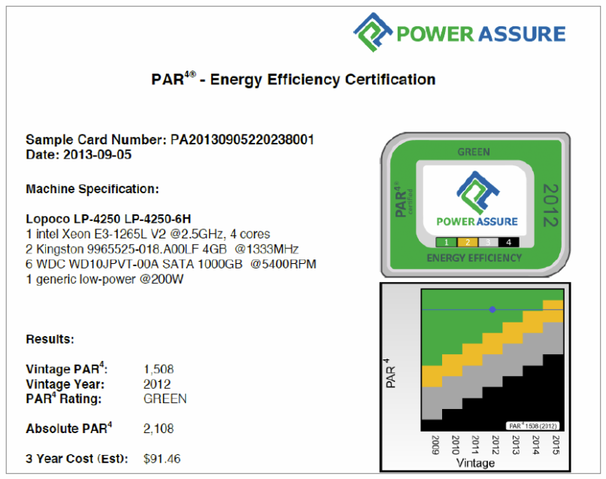Future: the energy consumption reductions will continue in future product lines with Lopoco designed motherboards, cases, and I/O devices

