
Light & Motion modified IT revamp proposal
Contact:
North America West Coast Headquarters
212 Thompson Sq., Mountain View, CA 94043
E-mail: info@lopoco.com Web: www.lopoco.com
Tel: 650.906.9448

New Virtual Machine Host
We propose to provide a pair of machines that will function as a Virtual Machine cluster, equally providing computing resources to whatever task needs them. The two machines clustered together will provide excellent long term growth capabilities and resiliency, as the VMs can be migrated from one machine to another. Additionally, if one of the servers fails, the VMs that were running on it can restart on the remaining machine with very little down time. All storage needs of the VMs will be replicated between the two machines, providing very short failover delays with minimal or no data loss. If, at any time, it is determined that more machine resources are necessary, additional machines can be purchased and added to the cluster. Each VM server in the cluster will have 12 logical cores, 128GB of ECC memory, and 4TB of replicated Raid-6 storage utilizing hybrid disk drives for good performance.
Due to this setup, I recommend that the 'landm' server become a either a VM on the VM cluster, or it's applications be moved over to an existing Linux VM that will be on that server. We can take care of handling that.

Dell PowerEdge 2900
Let RayneTech haul it away. The money they make recycling it should compensate them for the trouble. It is old, and extremely power hungy and wasteful, not to mention lacking performance compared to any modern computing technology. The two new VM servers together will use considerably less power than the PowerEdge 2900 all by itself. In fact, just the disk drives of the RayneTech proposed VM server will use more power than one of the Lopoco VM servers, nevermind the new disk drives they are proposing to buy for the PowerEdge 2900.

OS Licensing
We propose using Proxmox (Linux) as the VM host operating system. Professional support for ProxMox can purchased for $560/yr/machine for 10 support tickets, free upgrades, customer portal, etc, however we believe the best solution is to supply the support to Light & Motion ourselves at the same rate. That will provide L & M with a greater level of support because we will obtain and apply all updates, patches bug fixes in addition to handling the configuration and monitoring.
This will obviate the need for the $6k Microsoft Windows Datacenter License, and maybe also the 50 CAL (client access licenses), since you already have those with the SBS you have. According to Rayne, you can continue to use that without upgrading it, probably for another year. At that time, you can upgrade it, and the cost will likely be around $2k. I don't know if additional CAL licenses will be required. We can take a look at the clients you have, determine which ones could be thin clients running non-Windows operating systems, and determine a plan to put those in place.

Upgrade Firewall/Router and switch
Rayne wants to upgrade the SonicWall firewall appliance. The proposed Cisco 5512X is a very pricey, ultra-premium product that is drastic overkill for your application. I propose you stick with the appliance you have for another 6 months.
The 48-port Cisco switch sounds good to me. It's a good solid product, and the best you'd probably be able to do is find a product from HP for a hundred dollars cheaper, or a used one for half price. It's not that expensive to begin with, so I'd go with that.

Offsite DR Backup Services
Lopoco at this time would like to propose it's own cloud offsite backup service. This will be utilized for both offsite backup of xTuple database and backup of VM images. The cost is $260/mo. This represents $1,000 per year savings right off the bat, and includes the DR backup of the xTuple database, which the Datto service does not.

Managed Services and Support Heirarchy
Lopoco is proposing a small collection of managed services to go along with Light & Motion's IT needs. These will include various kinds of support as well as maintenance and monitoring.
VM Cluster Host environment support $560.00/yr
Software updates
Configuration
Issue resolution
Offsite DR Backup $3,120.00/yr
Disaster recovery backup of xTuple database
5 days/week; 4 weeks/mo; 12 months/yr
Disaster recovery backup of VM cluster
All templates; 3 daily snapshots; 1 weekly snapshot
Disaster recovery backup of backup server
5 days/week; 4 weeks/mo; 12 months/yr
These backup and support services will be provided in conjunction with some support and services provided by RTS. In order for you to have an effective support experience, it is necessary to outline the support heirarchy so that L & M employees know how to obtain support in an orderly and effective manner.

Support | Responsible provider
Windows Support, Desktop & Server | RTS
Email server | RTS
VM cluster software | Lopoco
xTuple application | (1) xTuple support, (2) Steve B., (3) Lopoco
Desktop user | RTS
Hardware support of Lopoco sourced servers | Lopoco
Timemachine backups | Lopoco

Backup Server
On-site backups is an essential part of any IT plan. Currently, RTS backs up the Windows SBS server, but nothing else is backed up. The xTuple machines are a replicating pair, but are not currently backed up anywhere.
We are proposing an on site backup server where backups can easily be stored and accessed for restoration or recovery options. The VMs that run on the VM cluster will be backed up nightly or even more often if desired, with full restorations or even temporary instantiations possible in just minutes. In addition, daily backups of the xTuple database will be stored on the backup server for added extra safety. And lastly but still importantly, client computers (laptops and desktops) will be backed up on the backup server, with backups of user files accessible directly by the user without administrator interaction.
Mac clients can be backed up using Timemachine, which allows users to access their own backups as well as a method for administrators to rebuild an entire hard drive. Windows and other clients can be backed up using equivalent software for those operating systems, with the Backup server operating as network storage. RTS can set that up on Windows clients as necessary.
Currently, backups for Mac clients is being done on the landm server, however I believe they have all lapsed, and nothing is being backed up at the present time. There are 10 Mac desktops and 4 laptops. We propose a low power microserver as a dedicated Backup server, with configured initially with 8 Terabytes of Raid-6 backup storage. This will handle existing machines, both virtual and real, and allow for a modest increase in the future in the number of clients.
This server will function as a generic network file server for Windows, Mac and Linux clients in order to facilitate their backup applications.

Uniterruptible Power Supply
Due to the problems encountered when power was lost last time, we propose that a more stable and professional UPS strategy be implemented. This would entail the removal of the old, mostly failing UPS boxes, and replacing them with a pair of APC SmartUPS X2000 rackmount units that can be installed in series, so when one peters out, the next one takes over. Moreover, the batteries are replaceable and recycleable, which is much more eco-friendly than meerly tossing them when the battery has expired. These units are about $1200 a piece, and will protect your IT equipment and data in the manner you really need. Furthermore, they can be configured to send you a message when the batteries need replacing, so that you don't encounter a situation where you need your UPS to save your bacon, but the batteries are dead, which is what happened last time because RTS wasn't on top of the situation. Which I consider to be a criticism of them, considering what they charge you monthly.
The install in the IT rack, rather than sitting on the floor under foot and so forth. They provide a predictive analysis of the day and date when the batteries will need replacing, which can be put in a calendar or reminder. Batteries are guaranteed for 2 years but expected to last 3 years.
These are not listed in the quote, but can be added upon request.

Cost Reductions
We estimate the following cost reductions versus the status quo and RTS latest proposal.

Product | RTS | Lopoco | Savings
Servers/networking hardware/software | $23,276.00 | $20,609.00 | $2,667.00
DR offsite backup; per year | $13,140.00 | $3,120.00 | $10,080.00
Replication management; per year | $2,400.00 | $560.00 | $1,840.00
Total this year | $14,587.00

Further cost savings not currently known: RTS is proposing a single price model for many IT management activities. One activity which you won't need is “Cloud data backup for workstations and servers.” However, they list that as $750/mo *Optional. That could mean that it's part of the 1651 monthly nut already, so that being eliminated would result in a $901 monthly from them in that case. But doubtful it is already included in that $1,651/mo, so I have included it in the table above.
Their managed services list doesn't include on-site backups, which Aaron said on the phone call that they are doing. Are those billed as an additional cost to the $1,651/mo (they couldn't make it $1,650?)? We would consider the on-site backup server proposed in this document to be a replacement for such services, so any additional cost savings for service would also need to be considered.


Quote
Item # | Description | Qty | Price | Total
1 | Lopoco LP-6240-8H 128GB 1U Server | 2 | $6,300.00 | $12,600.00
 | Power usage Idle: 40 watts/TDP: 110 watts
 | 2 x 64GB SSD for OS
 | 4TB Replicated Raid-6 Storage (6 x 1TB SSHD)
 | Hardware installation at customer site
2 | 2-year additional warranty | 2 | $340.00 | $680.00
3 | Software installation & configuration | 1 | $2,500.00 | $2,500.00
4 | Backup and TimeMachine Server LP-8240-8H 16GB | 1 | $3,799.00 | $3,799.00
 | Power usage Idle: 22 watts/TDP: 38 watts
 | 8TB of Raid-5 backup storage (6 x 2TB HDD)
 | Hardware installation at customer site
5 | 2-year additional warranty | 1 | $280.00 | $280.00
6 | Software installation & configuration | 1 | $750.00 | $750.00
Subtotal | $20,609.00
Tax | $1,393.92
Total | $22,002.92

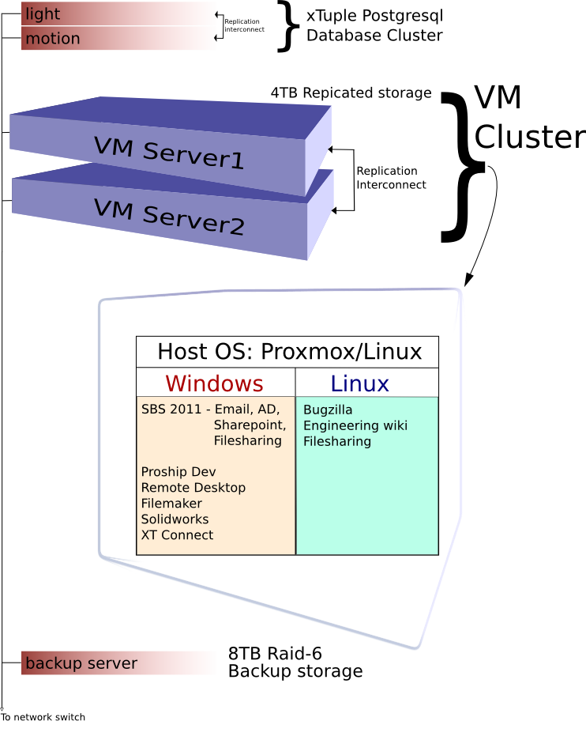
Systems & Applications Diagram

