**about lopoco**

designs and manufactures ultra‑efficient servers that use

25% of the power of conventional servers without compromising on performance or business continuity.

Our servers are built on proven, shipping technology

without costly custom silicon. Our technology is

disruptive to the industry, but not to the customer. All

our current products use Intel or AMD 64-bit X86 CPUs1.

**team insights**

led by founder Andrew Sharp, a Silicon Valley veteran

who joined Convergent Technologies in 1985, and has worked for Sun, SGI, HP and LSI, along with several startups.

Peter Theunis, CTO and co-founder, has more than

10 years of experience in large scale systems architecture

at startups and at Yahoo!

Jack Mills, VP Engineering, while at Intel was an architect

of the Pentium and the Itanium processors; later Director

of advanced processor research; also

an alumnus of Convergent Technologies [advisor]

Mark Brine, CFO, is a veteran of Silicon Valley startups, starting at VLSI, later VP of Finance at semiconductor

startup Discera; now Director of Finance at Cloudera [advisor/board].

Kripa Nithya, Director of Marketing, is **lopoco**'s

Marketing and partnership guru.

Karl Pfister-Kraxner is developing & driving the

commercials for our EMEA entity

**Validation, IP & traction**

* 8 provisional patents applied; additional patents

in preparation

* Revenue to date: >$100k
* 75+ Systems shipped
* 75% repeat customer rate
* Named “Most Efficient Certified to Date” by

Power Assure's PAR4 energy efficiency rating

system adopted by UL

* Data Guard Solutions Inc. (US/KSA), signed as distributor in GCC region
* Traction by Mobile Telecom Operators/global

Market Research companies

**value proposition**

conventional servers waste more than half the power they consume. Large data centers which pay for their own electricity and HVAC will be able to realize a 50% reduction in OpEx costs by adopting lopoco products – savings which go straight to the bottom line. Data center experts report that they pay between $50-$100 per watt for the power used by the servers when constructing a data center. This translates to $100s of millions in potential savings.

**market**

The Total Addressable Market is $40-$50bb globally. Projected to be $70bb in 5-8 years, fueled by acceleration of cloud adoption and mobile application space. According to IDC, they see signs of a server refresh cycle, which we expect will continue to lift the market into 2015 and onwards.

**lopoco target market** focus on SME and Data Center Providers

**lopoco commercial vision** in 5 years: SAM: $60bb; SOM: $12bb.

**required funding**

looking for seed level investment right now ($200k convertible note) with the following milestones:  
  
Take the company through the next 6-9 months with the following goals over that time:

* fund commercial entry into European Markets
* get the company in a position to seek Series A funding in 6-9 months
* fund targeted marketing and PR efforts with the goal of adding new customers
* ramping up operations (manufacturing/fulfilment), engineering and
* customer support to handle +100 customers (most of this will be driven by product orders and funded by the resulting revenue, but some small amounts of funding will be needed ahead of orders.

**Team contacts**

ceo: Andrew Sharp [andy@lopoco.com](mailto:andy@lopoco.com)

soft: Peter Theunis [peter@lopoco.com](mailto:peter@lopoco.com)

hard: Jack Mills [jack@lopoco.com](mailto:jack@lopoco.com)

finance: Mark Brine mark@lopoco.com

market: Kripa Nithya [kripa@lopoco.com](mailto:kripa@lopoco.com)

europe: Karl Pfister-Kraxner [karl@lopoco.com](mailto:karl@lopoco.com)

**irresistible Value Proposition**

**lopoco** green tech servers help data centers shred their monthly operating costs by 50% or more.

All while preserving business continuity and compliance

with conventional form factors, CPUs, and server options already familiar to customers.

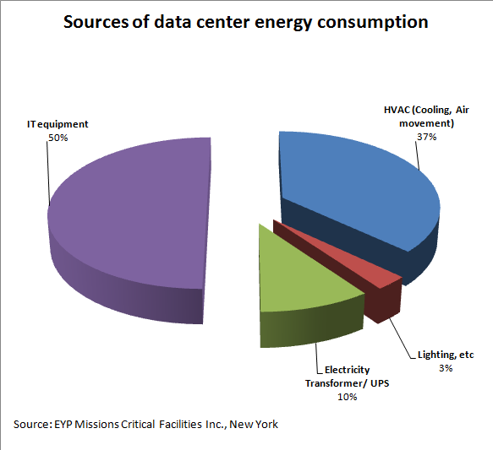

The chart above shows that, except for lighting costs, a customer can save operating costs in all areas of data center operations by deploying **lopoco** servers.

**go to market in Europe**

priority european countries UK, Italy and Germany as the face the highest electricity costs per KW. Highest value add based on tested and proven energy savings as Power Assure certified.

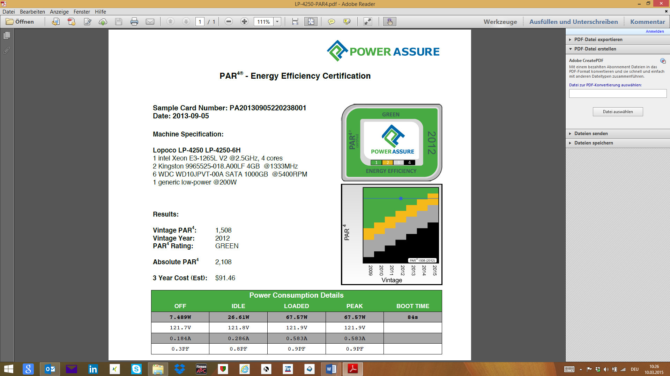

**Economy of scale**

Currently manufacturing in California by 2 optional Contract manufacturers with capabilities to expand to sites in overseas.

Components used are industry standard.

**client´s potential savings**

the bar chart below illustrates the savings customers (20₵/KwH) can realize when utilizing lopoco servers.

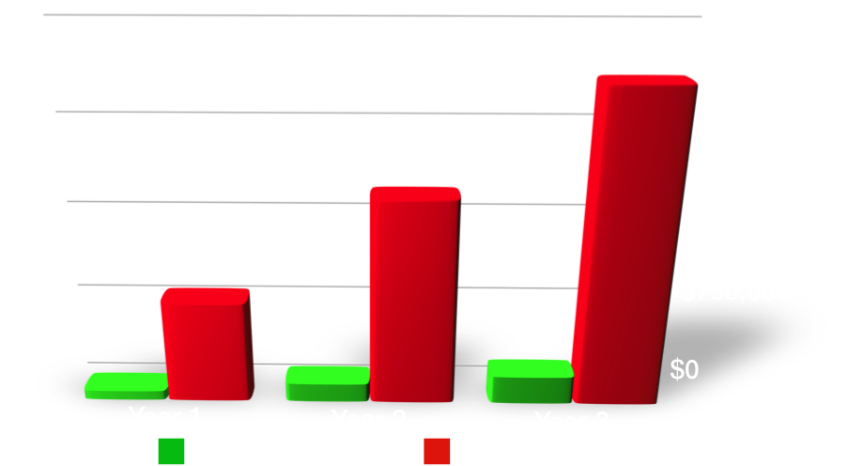

TCO per 1000 servers for 3 years.

**competition**

Our main competition is the top tier server vendors, and while they do not make a direct competitive product, they are plenty of competition. Multiple self-styled efficient server startups (Calexda/Tilera, HP Moonshot, Seamicro, Servergy) are all making products with similar problems: costly; high power; proprietary silicon and packaging; weird processors; dubious efficiency. Put simply, they are making servers nobody wants. With high adoption risk and providing no business continuity, these products are seeing very little adoption in the market, and have a very small SAM compared to lopoco. [Note: Calexda closed doors 1/2014]

[Note: Seamicro acquired by AMD $335M 2014]

**exit**

Our disruptive product, combined with the acquisition aggressive server/storage industry indicates the most likely exit will be through acquisition. $400mm revenue in 3 years -> likely $4bb acquisition valuation.

Similars:

* Arista acquired by HP Jan. 2015 $3B
* SeaMicro acquired by AMD Mar. 2013 $335M
* Wyse acquired by Dell 2012 <$1B
* Cobalt Networks acquired by Sun 2000 $2B