### 

### contact

Low Power Company, Inc.

www.lopoco.com

[info@lopoco.com](mailto:info@lopoco.com)

@lowpowercompany

### team

ceo: Andrew Sharp [andy@lopoco.com](mailto:andy@lopoco.com)

soft: Peter Theunis [peter@lopoco.com](mailto:peter@lopoco.com)

hard: Jack Mills [jack@lopoco.com](mailto:jack@lopoco.com)

market: Kripa Nithya [kripa@lopoco.com](mailto:kripa@lopoco.com)

**lopoco** is led by founder Andrew Sharp, a Silicon Valley veteran who joined Convergent Technologies in 1985, and has worked for Sun, SGI, HP and LSI, along with several startups.

Peter Theunis, CTO and co-founder, has more than 10 years of experience in large scale systems architecture at startups and at Yahoo!

Jack Mills, VP Engineering, while at Intel was an architect of the Pentium and the Itanium processors; later Director of advanced processor research; also an alumnus of Convergent Technologies [advisor]

Mark Brine, CFO, is a veteran of Silicon Valley startups, starting at VLSI, later VP of Finance at semiconductor startup Discera; now Director of Finance at Cloudera [advisor/board].

Kripa Nithya, Director of Marketing, is **lopoco**'s marketing and partnership guru.

### executive summary

**lopoco** designs and manufactures ultra‑efficient servers that use 25% of the power of conventional servers without compromising on performance or business continuity. Our servers are built on proven, shipping technology without costly custom silicon. Our technology is disruptive to the industry, but not to the customer. All our current products use Intel or AMD 64-bit X86 CPUs1.

### validation & traction

* Revenue to date: >$100k [August 2014]
* 75% repeat customer rate
* 75+ Systems shipped
* Named “Most Efficient Certified to Date” by Power Assure's PAR4 energy efficiency rating system adopted by UL
* Data Guard Solutions signed as distributor in GCC region

### value proposition

Conventional servers waste more than half the power they consume. Large data centers which pay for their own electricity and HVAC will be able to realize a 50% reduction in OpEx costs by adopting lopoco products – savings which go straight to the bottom line. Data center experts report that they pay between $50-$100 per watt for the power used by the servers when constructing a data center. This translates to $100s of millions in savings.

### market

The Total Addressable Market is $40-$50bb globally. Projected to be $70bb in 5-8 years, fueled by acceleration of cloud adoption and mobile application space. **lopoco** in 5 years: SAM: $60bb; SOM: $12bb.

### ip

8 provisional patents; more on the way.

## Irresistible Value Proposition

**lopoco** green tech servers help large data centers shred their monthly operating costs by 50% or more.

*All while preserving business continuity and compliance with conventional form factors, CPUs, and server options already familiar to customers.*

The chart above shows that, except for lighting costs, a customer can save operating costs in all areas of data center operations by deploying **lopoco** servers.

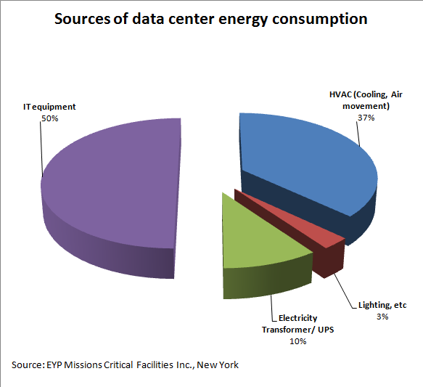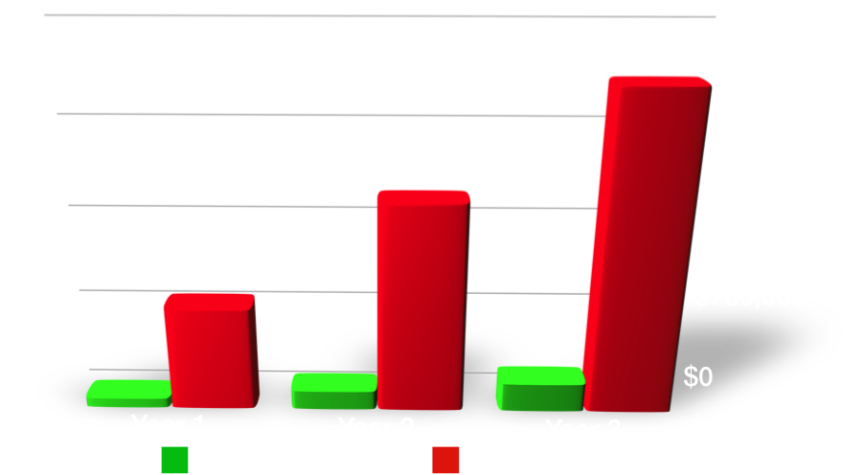

### go to market strategy

blah de blah de blah SMB, small cloud providers

### competition

Our main competition is the top tier server vendors, and while they do not make a direct competitive product, they are plenty of competition. Multiple self-styled efficient server startups (Calexda/Tilera, HP Moonshot, Seamicro, Servergy) are all making products with similar problems: costly; high power; proprietary silicon and packaging; weird processors; dubious efficiency. Put simply, they are making servers nobody wants. With high adoption risk and providing no business continuity, these products are seeing very little adoption in the market, and have a very small SAM compared to **lopoco**. [Note: Calexda closed doors 1/2014]

[Note: Seamicro acquired by AMD $335M 2014]

### exit

Our disruptive product, combined with the acquisition aggressive server/storage industry indicates the most likely exit will be through acquisition. $400mm revenue in 3 years -> likely $4bb acquisition valuation.

Similars:

* Arista acquired by HP Jan. 2015 $3B
* SeaMicro acquired by AMD Mar. 2013 $335M
* Wyse acquired by Dell 2012 <$1B
* Cobalt Networks acquired by Sun 2000 $2B