**ME Firmware Update Guide for HuronRiver & ChiefRiver**

**Document Revision 0.3**

**Jun 29, 2012**

This document has installation instructions to update your computer with the latest ME firmware version.

1. During the boot, enter the BIOS setup by pressing **Delete** key.
2. Browse through the BIOS menu, go to Exit page.

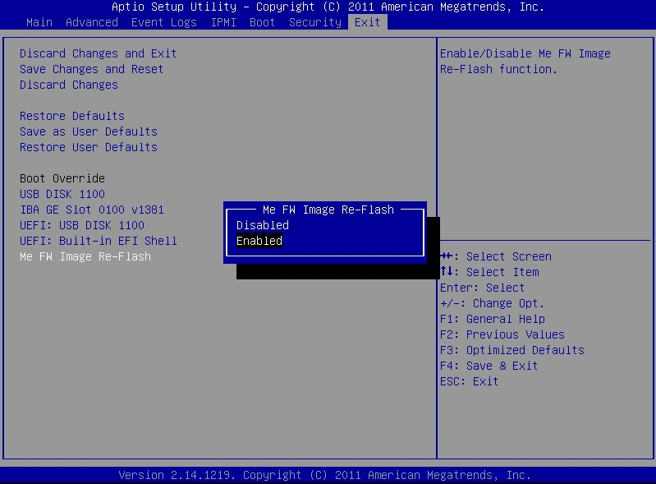

1. Select “ME FW Image Re-Flash” and enable it.
2. Select “Save Changes and Reset” to restart the system and boot to your USB flash drive.

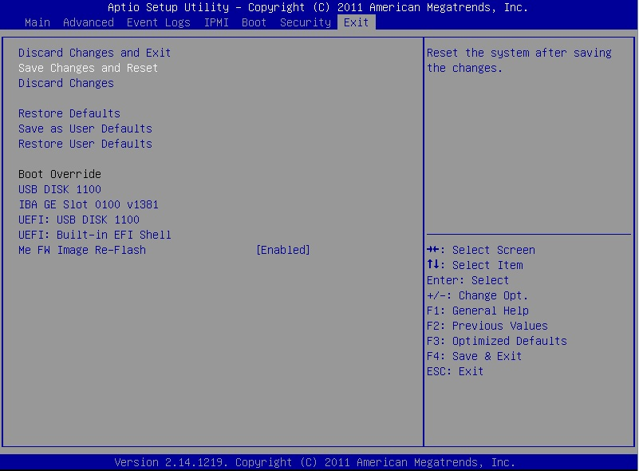

1. The system will boot from the bootable USB Flash Drive that contains the BIOS flash package.
2. To start flashing BIOS in DOS mode, enter:

afudos x9spvf.bin /p /b /n /k /r /me

Note: The exact .BIN file can be found in the BIOS flash package.

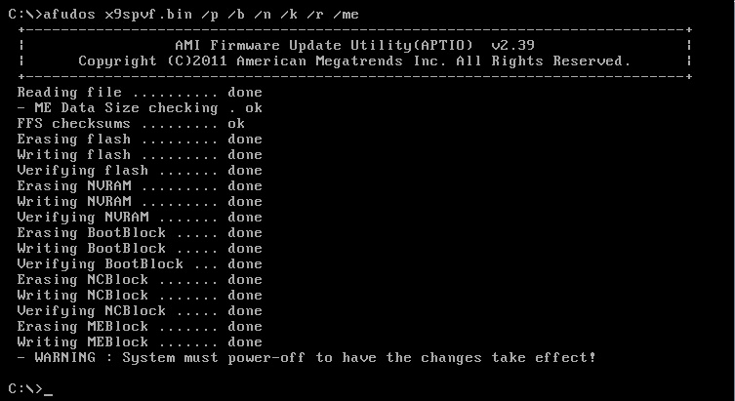

7. After the update finishes, power off the system and restart the system.