

PS2 Connectors

USB Ports

VGA port

IPMI LAN Port

Contact information: [www.lopoco.com](http://www.lopoco.com/)

support@lopoco.com

Serial DB9

LAN Port 0

LAN Port 1

UID switch

IPMI heartbeat LED

LP-6240 Quick reference guide v. 1.0

Back panel

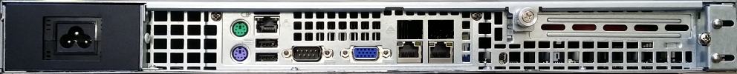

Power cable

For console access, use the PS/2 and VGA ports, or use the network KVM feature via the IPMI LAN port. The IPMI IP address will acquired and set via DHCP by default. An IP address can be configured via IPMI (consult your IPMI software application documentation), via the web based BMC interface, or in the BIOS. Simply point your browser to the IP address assigned to the IPMI port, and log into the GUI. Default user/password is ADMIN/ADMIN . For security reasons, change the password and/or the user after the system is installed. Full user access configurability is available via the web interface.

For nKVM access, from the web interface, click on the console image on the first page. This will launch the java network console application. From this application, virtual media may be configured for system booting and software installation purposes, removing the need for a CD/DVD drive. The IPMI heartbeat LED blinks when the IPMI/BMC is ready for use; off when not ready.

All LAN ports have two LEDs, one indicating carrier link established (100BT: green; 1Gb: yellow), and the other blinks to indicate network packets being transmitted or received. In addition, the front panel has a single LED for each LAN port that combines both carrier link and network traffic in one LED.

The UID switch, off by default, is recessed and can be actuated with a slim tool. This will illuminate the UID indicator LED on the front and rear panels of the server for easier identification. Press the switch a second time to turn off the LEDs.

Front panel

LEDs: power on, LAN 0, LAN 1, OH/Fan fail, and UID. The Over Heat/Fan Fail LED will illuminate if the server is exeriencing an OH condition, and will flash if a fan fail is detected.

Switches: 25mm power switch; recessed 10mm reset switch.